Sql server advanced 14

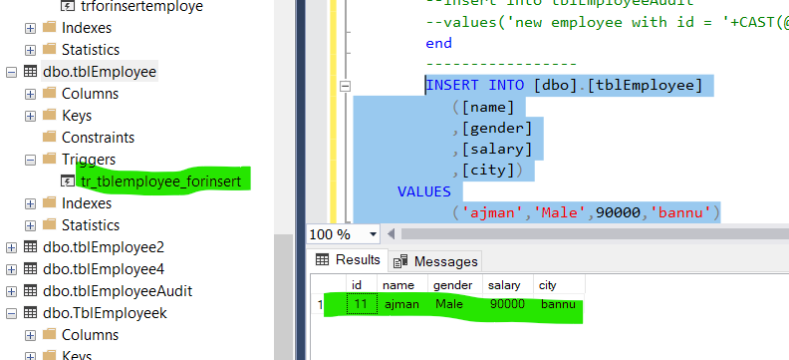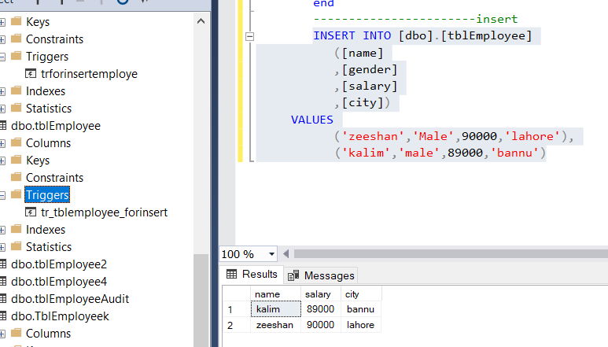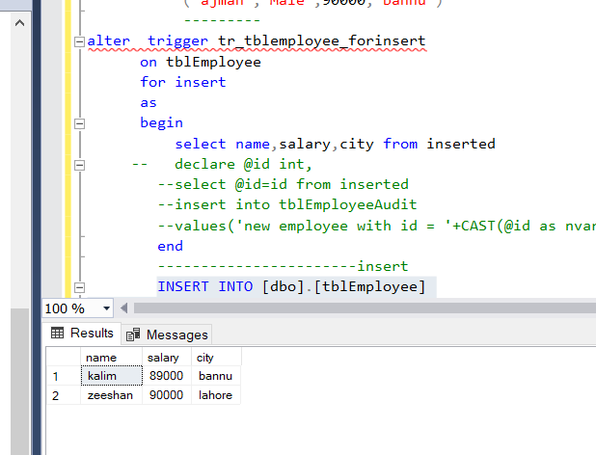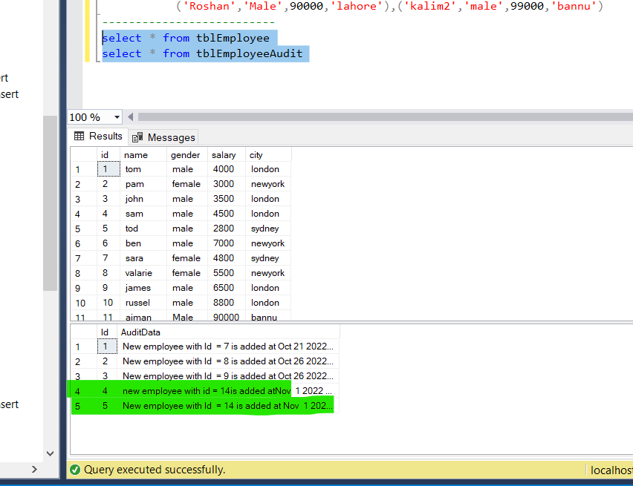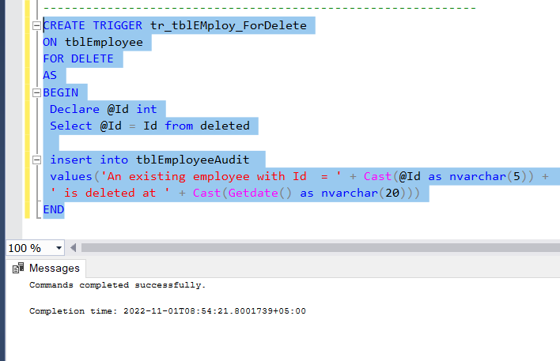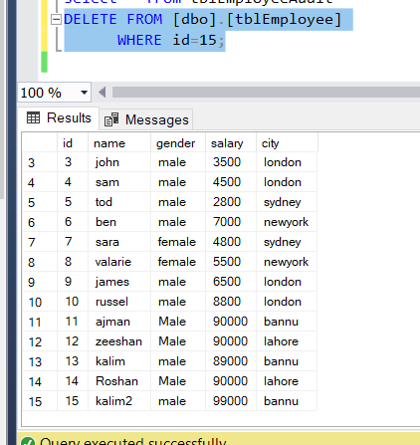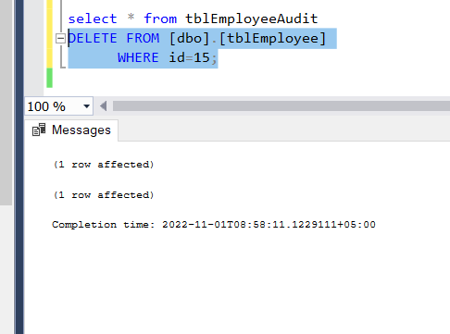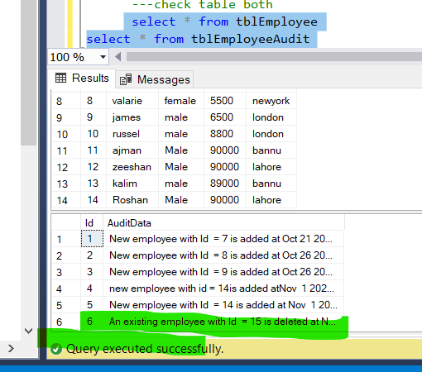

select * from Employee2

-----

create proc sp_emplnamegender

as

begin

select ID,

Name,Gender from

Employee2

end

-- exex

exec sp_emplnamegender

----------------------------

select * from test5

-------------------

create proc sp_test5_id_name

(@id int,

@name nvarchar(50),

@age int

)

as

begin

insert into test5(id,name,age)

values(

@id,@name,@age

)

end

---exec

exec sp_test5_id_name 18,'suliman khan',34

exec sp_test5_id_name 19,'Noman khan',36

select * from test5

sp_help sp_test5_id_name

sp_helptext sp_test5_id_name

sp_rename 'sp_test5_id_name' , 'Sp_Test5idname'

----------------------------

CREATE PROCEDURE uspUpdateEmpSalary

(

@empId int

,@salary float

)

AS

BEGIN TRY

UPDATE tblEmploye

SET Salary = @salary

WHERE ID = @empId

END TRY

BEGIN CATCH

SELECT

ERROR_NUMBER() as ErrorNumber,

ERROR_SEVERITY() as ErrorSeverity,

ERROR_STATE() as ErrorState,

ERROR_MESSAGE() as ErrorMessage;

END CATCH

select * from tblEmploye

exec uspUpdateEmpSalary 3,85000

----

create proc sp_employee_salaraymoney

@id int,

@salary money

as

begin

update tblEmploye

set Salary= @salary

where ID=@id

end

-----------------

exec sp_employee_salaraymoney 2,99000

select * from tblEmploye

----lets take another examples

select * from player

create proc sp_Playerproc

(@rank int,

@name nvarchar(20),

@best int)

as

begin

insert into player(rank,name,best)

values

(@rank,@name,@best)

end

---

exec sp_Playerproc 6,'ajman',198

-----

select * from player

select * from tblDepartment

create proc sp_Departmenthead

@empid int,

@Dephead nvarchar(20) output

as

begin

select DepartmentHead=@Dephead

from tblDepartment

where ID=@empid

end

---execution

declare @Dephead varchar(20)

exec sp_Departmenthead 5,@Dephead output

print @Dephead

--------------create cluster indexes

CREATE TABLE EmployeeDetails(

EmployeeID int NOT NULL,

PassportNumber varchar(50) NULL,

ExpiryDate date NULL)

Insert into EmployeeDetails values(3,'A5423215',null);

Insert into EmployeeDetails values(5,'A5423215',null);

Insert into EmployeeDetails values(2,'A5423215',null);

Insert into EmployeeDetails values(8,'A5423215',null);

Insert into EmployeeDetails values(1,'A5423215',null);

Insert into EmployeeDetails values(4,'A5423215',null);

Insert into EmployeeDetails values(6,'A5423215',null);

Insert into EmployeeDetails values(7,'A5423215',null);

-------

select * from EmployeeDetails

---create clustered index

CREATE CLUSTERED INDEX CIX_EmpDetails_EmpId

ON EmployeeDetails(EmployeeID);

---

select * from EmployeeDetails

----

create clustered index Cix_empdetails_idandPass

on EmployeeDetails(EmployeeID ASC,PassportNumber Desc);

----Drop index

Drop index CIX_EmpDetails_EmpId

on EmployeeDetails;

---create another

create clustered index Cix_empdetails_idandPass

on EmployeeDetails(EmployeeID ASC,PassportNumber Desc);

------check table

select * from EmployeeDetails

-- drop cluter index

select * from tblEmployee

--- create non-clustored index

select * from Person

create nonclustered index ncix_Email

on Person(Email);

--- crete trigger

CREATE TABLE EmpLog (

LogID int IDENTITY(1,1) NOT NULL,

EmpID int NOT NULL,

Operation nvarchar(10) NOT NULL,

UpdatedDate Datetime NOT NULL

)

CREATE TABLE TblEmployeek (

LogID int IDENTITY(1,1) NOT NULL,

EmpID int NOT NULL,

Operation nvarchar(10) NOT NULL,

UpdatedDate Datetime NOT NULL

)

------------------

CREATE TRIGGER trgEmployeeKInsert

ON TblEmployeek2

FOR INSERT

AS

INSERT INTO EmpLog(EmpID, Operation, UpdatedDate)

SELECT DepartmentID ,'INSERT',GETDATE() FROM INSERTED; --virtual table INSERTED

---------------

create table TblEmployeek2(FirstName nvarchar(20),

LastName nvarchar(20)

,EMail nvarchar(20)

,Phone int

,HireDate date

,ManagerID int

,Salary int

,

DepartmentID int )

INSERT INTO TblEmployeek2

VALUES('Manisha2'

,'Dutt2'

,'MD456@abc.com'

,689

,'11/07/2015'

,7

,50000

,30),

('Manisha5'

,'Dutt5'

,'MD456@5abc.com'

,676

,'11/07/2015'

,9

,50000

,35)

----------------

select * from EmpLog

select * from TblEmployeek2

insert into TblEmployeek2 values('ajman','khan','ajman41288@gmail.com',678,'11/08/2022',76,780000,67)

select * from EmpLog

select * from TblEmployeek2

---- create trigger

select * from sales2

select * from sales

create trigger trgsalesinsert

on sales

for insert

as

insert into sales2(customername,productname,Salary,vendorname)

select customername,productname, 'INSERT', getdate() from inserted;

insert into sales values('ajman','perfume',67000,'batta')

----after insert

CREATE TRIGGER trgEmployeeKafterinsert

ON TblEmployeek2

after update

AS

INSERT INTO EmpLog(EmpID, Operation, UpdatedDate)

SELECT DepartmentID ,'INSERT',GETDATE() FROM INSERTED; --virtual table INSERTED

--------------------

insert into TblEmployeek2 values('ajmanullah','khan','ajman41288@gmail.com',698,'11/08/2022',86,980000,87)

select * from EmpLog

select * from TblEmployeek2

CREATE TRIGGER dbo.trgInsteadOfDelete

ON TblEmployeeK2

INSTEAD OF DELETE

AS

INSERT INTO EmpLog(EmpID, Operation, UpdatedDate)

SELECT DepartmentID,'DELETE', GETDATE() FROM DELETED;

DELETE FROM TblEmployeek2

WHERE DepartmentID = 87;

---check both table

select * from EmpLog

select * from TblEmployeek2

------

select * from tblEmployee

select * from tblEmployeeAudit

sp_helptext trforinsertemploye

---

create trigger tr_tblemployee_forinsert

on tblEmployee

for insert

as

begin

select * from inserted

-- declare @id int,

--select @id=id from inserted

--insert into tblEmployeeAudit

--values('new employee with id = '+CAST(@id as nvarchar(5))+ 'is added at '

end

-----------------

INSERT INTO [dbo].[tblEmployee]

([name]

,[gender]

,[salary]

,[city])

VALUES

('ajman','Male',90000,'bannu')

---------

alter trigger tr_tblemployee_forinsert

on tblEmployee

for insert

as

begin

select name,salary,city from inserted

-- declare @id int,

--select @id=id from inserted

--insert into tblEmployeeAudit

--values('new employee with id = '+CAST(@id as nvarchar(5))+ 'is added at '

end

-----------------------insert

INSERT INTO [dbo].[tblEmployee]

([name]

,[gender]

,[salary]

,[city])

VALUES

('zeeshan','Male',90000,'lahore'),

('kalim','male',89000,'bannu')

-------------------

select * from tblEmploye

alter trigger tr_tblemployee_forinsert

on tblEmployee

for insert

as

begin

declare @id int

select @id=id from inserted

insert into tblEmployeeAudit

values('new employee with id = '+ CAST(@id as nvarchar(5))+ 'is added at'+ CAST(getdate() as nvarchar(20)))

end

-------------------------------------------------------------------------

CREATE TRIGGER tr_tblEMploy_ForInsert

ON tblEmployee

FOR INSERT

AS

BEGIN

Declare @Id int

Select @Id = Id from inserted

insert into tblEmployeeAudit

values('New employee with Id = ' + Cast(@Id as nvarchar(5)) + ' is added at ' + cast(Getdate() as nvarchar(20)))

END

--------

select * from tblEmployee

INSERT INTO [dbo].[tblEmployee]

([name]

,[gender]

,[salary]

,[city])

VALUES

('Roshan','Male',90000,'lahore'),('kalim2','male',99000,'bannu')

--------------------------

select * from tblEmployee

select * from tblEmployeeAudit

-------------------------------------------------------------

CREATE TRIGGER tr_tblEMploy_ForDelete

ON tblEmployee

FOR DELETE

AS

BEGIN

Declare @Id int

Select @Id = Id from deleted

insert into tblEmployeeAudit

values('An existing employee with Id = ' + Cast(@Id as nvarchar(5)) +

' is deleted at ' + Cast(Getdate() as nvarchar(20)))

END

----------------

select * from tblEmployeeAudit

DELETE FROM [dbo].[tblEmployee]

WHERE id=15;

---check table both

select * from tblEmployee

select * from tblEmployeeAudit

